# Background

Big Mountain Resort is a ski resort located in Flathead National Forest, Montana. It offers skiing & snowboarding experience for over 350,000 visitors on 105 trails. The resort is equiped with 11 lifts, 2 T-bars, and 1 magic carpet.

Recently, the resort installed a new chair lift to help increase the distribution of visitors across the mountain. It increases operating costs by $1,540,000 this season. The management board of the resort wants to implement data-driven solutions to revise its ticket price as well as its business strategies to reduce operation costs.

# Approach

The Data Science Method (DSM) is applied to help the management board to find the solutions. The DSM includes six steps: problem identification, data wrangling, exploratory data analysis, data preprocessing and data training, modeling, and documentation.

Two data sets are used for the study: a ski data set that includes all US’s ski resorts’ names and their associated information as well as population information from each state. The data sets are cleaned utilizing data cleaning tools in the data wrangling stage. A series of data exploration strategies are applied to datasets to understand the correlation among different parameters. **Figure 1** shows the correlation heatmap developed from the analysis: a brighter color represents a strong positive correlation, and a darker square means a strong negative correction.

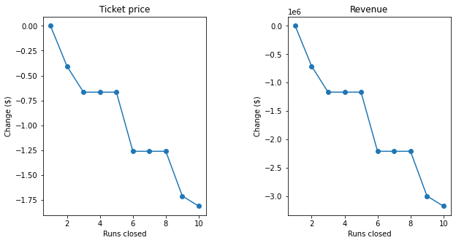

After data preprocessing and data training, two machine learning models are used for the data analysis: Linear Regression & Random Forest Model. The Random Forest Model shows stronger R value (coefficient of determination) compared with the one with the Linear Regression model. The Random Forest Model is used for recommendation strategy development. As an example, **Figure 2** shows the relationship between Ticket Price/Revenue and the number of Ski Runs closed.

# Recommendations

The developed model is used to gain insights into what pricing the resort might support as well as exploration of the sensitivity of changes to various resort parameters.

### Ticket Pricing

It is recommended that the pricing of the resort can be increased. The modeled ticket price (Adult Weekend Price) is $95.87. The current price is $81. Even though the model shows a mean absolute error of $10.39 (the predicted pricing could be between $85.48 - $106.26), it suggests that there is room for a ticket price increase. Comparing the facilities within the resorts with other resorts in the States, the Big Mountain Resort has a high number of snow making areas, high number of total charis, fast quads, runs, and large amounts of skiable terrain. All above mentioned data allows for the resort to charge a relatively higher ticket price for what it can offer.

### Runs vs. Revenue/Ticket Price

### The model suggests that when one run is closed, the ticket price/revenue is not influenced; however, closing 2 and 3 successively reduces support for the ticket price/revenue. When the resort closes down 3-5 runs, the model indicates that there is no further loss in ticket price. Increasing the run closures down to 6 or 9 more can lead to a large drop.

### Business Strategies Discussion

The following business options are discovered in the model:

* **Option 1:** Increase the vertical drop by adding a run to a point 150 feet lower down but requiring the installation of an additional chair lift to bring skiers back up, without additional snow making coverage.
* **Option 2**: Same as **Option 1**, but adding 2 acres of snow making cover.
* **Option 3**: Increase the longest run by 0.2 mile to boast 3.5 miles length, requiring an additional snow making coverage of 4 acres.

Based on the developed model, **Option 1** allows for the resort to increase its ticket price by $1.99, which is around $3.47M by the end of the season. By adding 2 acres of snow making cover as suggested in **Option 2** on top of **Option 1**, the model suggests that the ticket price would not be affected. Furthermore, when the longest run is increased by 0.2 mile as suggested in **Option 3**, the model also predicts that the price may not be increased.

# Summary

The DSM is used to help the Big Mountain Resort to find sound business strategies for the up-coming seasons. Data science models are developed based on collected information, and a machine learning model is used to find the answers for the management board. As a result, the model suggests that the ticket price for the resort can be increased, as well as what business strategy can impact the ticket pricing.